Spectral coherence: GBPUSD and NZDUSD
Method 21 / daily log returns / Welch magnitude-squared coherence / Alpari D1 full available history

Study setup
Logical pair: GBPUSD , NZDUSD
Broker symbols: GBPUSD_i , NZDUSD_i
Snapshot: 2026-11-03_majors_alpari_D1
Timeframe: D1
Matched return window: 1999-01-05 to 2026-11-02 (UTC bar dates)
Matched return count n: 7203
Dropped unfinished last bar dated 2026-11-03 UTC after a tick-volume check against the prior complete day.
Welch: fs=1.0, nperseg=256, noverlap=128, window=hann, detrend=constant
Headline: gamma^2 nearest f=1/5; also 1/21 and 1/63
Complete matched rows (Excel): GBPUSD-NZDUSD_Spectral_D1.xlsx
Complete matched rows (HTML table): GBPUSD-NZDUSD_Spectral_D1_data.html

Method carried forward
Magnitude-squared spectral coherence gamma^2(f) measures shared linear power between matched daily log returns of close, ln(close_t / close_t-1), at each frequency f (cycles per day). Quotes are not inverted. Welch settings are frozen: fs=1, nperseg=256, noverlap=128, window=hann, detrend=constant. Headline is gamma^2 at the frequency bin nearest f=1/5 (five-day cycle from the formula sheet). Also reported: gamma^2 nearest f=1/21 and f=1/63, mean gamma^2 over the frequency grid, and phase of the cross-spectrum at the 1/5 bin. Coherence is unsigned (0 to 1); phase carries timing. Same-sample Pearson r is a side check only. This is not causation and not a trading signal.

Results (headline)
gamma^2 near 1/5: 0.195704
bin f (1/5): 0.199219
phase at 1/5 (rad): -0.059550
gamma^2 near 1/21: 0.338329
gamma^2 near 1/63: 0.334047
mean gamma^2: 0.302741
Pearson r: 0.530079

Target-frequency summary
period | target_f | f_bin | gamma2 | phase_rad
5 | 0.2 | 0.19921875 | 0.19570364 | -0.05954999
21 | 0.04761905 | 0.046875 | 0.33832924 | 0.23523729
63 | 0.01587302 | 0.015625 | 0.33404678 | 0.25069279

Conclusion
Headline gamma^2 near f=1/5 for GBPUSD and NZDUSD: 0.1957 (bin f=0.199219, phase=-0.0595 rad). At ~1/21: 0.3383; at ~1/63: 0.3340. Mean gamma^2 = 0.3027. Pearson r = 0.5301. This is frequency-domain linkage, not a trading signal.

Charts
Daily closes

Daily log returns

Spectral coherence gamma^2(f)
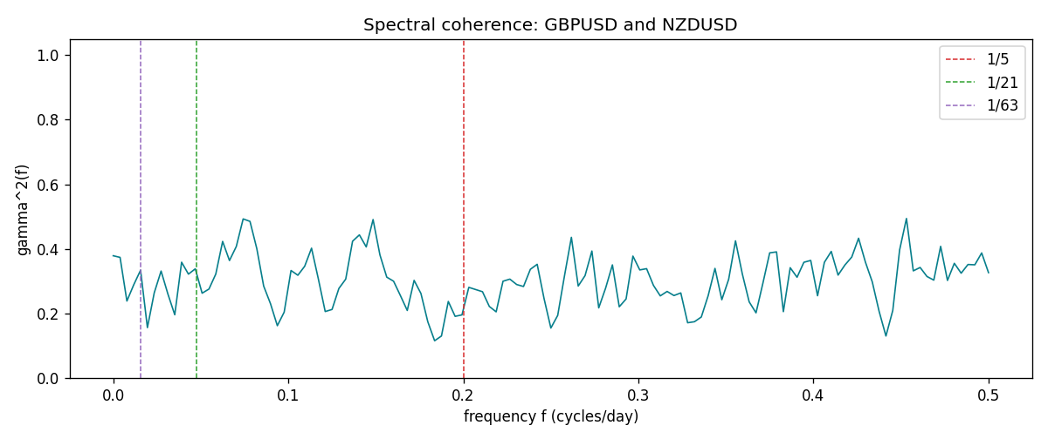

Data report
Matched rows and the coherence sheet are in the sibling Excel workbook named GBPUSD-NZDUSD_Spectral_D1.xlsx. Embedding all rows as a Word table is impractical; this file holds column summaries and the first and last 15 matched rows.
Columns: time, GBPUSD_open, NZDUSD_open, GBPUSD_high, NZDUSD_high, GBPUSD_low, NZDUSD_low, GBPUSD_close, NZDUSD_close, GBPUSD_tick_volume, NZDUSD_tick_volume, GBPUSD_spread, NZDUSD_spread, GBPUSD_real_volume, NZDUSD_real_volume, GBPUSD_log_return, NZDUSD_log_return
Column summaries (matched calculation rows)
column | count | mean | std | min | 25% | 50% | 75% | max
GBPUSD_open | 7203 | 1.5160351 | 0.21820856 | 1.06854 | 1.32502 | 1.51126 | 1.63163 | 2.1066
NZDUSD_open | 7203 | 0.65617721 | 0.10827592 | 0.3913 | 0.59107 | 0.6683 | 0.72469 | 0.88218
GBPUSD_high | 7203 | 1.5223294 | 0.21877071 | 1.08366 | 1.3298 | 1.51797 | 1.63833 | 2.1161
NZDUSD_high | 7203 | 0.66009189 | 0.10877133 | 0.3961 | 0.594565 | 0.67188 | 0.729235 | 0.88421
GBPUSD_low | 7203 | 1.5097156 | 0.21743942 | 1.03518 | 1.319525 | 1.50315 | 1.62431 | 2.0983
NZDUSD_low | 7203 | 0.65248767 | 0.1078698 | 0.3897 | 0.587935 | 0.66402 | 0.72082 | 0.87988
GBPUSD_close | 7203 | 1.5161019 | 0.21816437 | 1.06879 | 1.32515 | 1.51122 | 1.63196 | 2.1065
NZDUSD_close | 7203 | 0.65624807 | 0.10827144 | 0.3907 | 0.591395 | 0.6683 | 0.724915 | 0.8822
GBPUSD_tick_volume | 7203 | 94800.961 | 153533.35 | 62 | 9991 | 52873 | 91772.5 | 1273370
NZDUSD_tick_volume | 7203 | 68552.383 | 123030.52 | 16 | 5500.5 | 33815 | 58467.5 | 1127682
GBPUSD_spread | 7203 | 26.976121 | 19.194852 | 0 | 11 | 20 | 50 | 50
NZDUSD_spread | 7203 | 30.373178 | 25.676979 | 0 | 9 | 17 | 50 | 80
GBPUSD_real_volume | 7203 | 3.5551025e+09 | 8.4426509e+10 | 0 | 0 | 0 | 0 | 2.4038164e+12
NZDUSD_real_volume | 7203 | 1.6657093e+10 | 8.4881524e+10 | 0 | 0 | 0 | 0 | 2.705649e+12
GBPUSD_log_return | 7203 | -2.372e-05 | 0.00564203 | -0.08388241 | -0.00312422 | 3.221e-05 | 0.0031735 | 0.03112653
NZDUSD_log_return | 7203 | 5.29e-06 | 0.00764545 | -0.07027433 | -0.00426254 | 0.00021291 | 0.00457891 | 0.05966839
First 15 matched rows (selected columns)
time | GBPUSD_log_return | NZDUSD_log_return
1999-01-05 | -0.0028966287 | -0.0018597736
1999-01-06 | -0.00060452184 | 0.0020455609
1999-01-07 | -0.002118709 | 0.0062963171
1999-01-08 | -0.0058954193 | -0.00055396548
1999-01-11 | -0.0056851331 | 0.010290425
1999-01-12 | 0.0022657001 | -0.0053157489
1999-01-13 | 0.0091330396 | -0.0099742238
1999-01-14 | 0.0019376331 | -0.00018564931
1999-01-15 | -0.0017558204 | -0.00074294208
1999-01-18 | 0.0012112405 | -0.0018597736
1999-01-19 | 0.0018745281 | 0.0018597736
1999-01-20 | -0.0049053846 | 0.0040793678
1999-01-21 | 0.0031518998 | 0.0040627941
1999-01-22 | 0.0024781662 | -0.012051689
1999-01-25 | 0.0012066366 | -0.0035504102
Last 15 matched rows (selected columns)
time | GBPUSD_log_return | NZDUSD_log_return
2026-10-13 | 0.0036434319 | 0.0047326165
2026-10-14 | -0.0049164679 | -0.0037306483
2026-10-15 | 0.0065976411 | 0.0047634855
2026-10-16 | 0.0037592051 | 0.0057501001
2026-10-19 | -0.0017500314 | 0.0018917133
2026-10-20 | 0.0055923442 | 0.0037199341
2026-10-21 | 0.0012476328 | 0.0030923331
2026-10-22 | 0.00022396082 | -0.0033035227
2026-10-23 | -0.0021146949 | 0.0030929853
2026-10-26 | -0.0024340661 | -0.0028993932
2026-10-27 | -0.0023648393 | -0.00026399852
2026-10-28 | 0.0015771808 | -0.0097283914
2026-10-29 | 0.0035881935 | 0.00062190714
2026-10-30 | 0.0013450605 | 0.00019537668
2026-11-02 | 0.0010971256 | -0.0025962955
First 15 frequency bins
f | gamma2 | phase_rad | period_days
0 | 0.37888449 | 0 | inf
0.00390625 | 0.37385089 | 0.0327754 | 256
0.0078125 | 0.2385846 | 0.19739421 | 128
0.01171875 | 0.28896404 | 0.21850994 | 85.333333
0.015625 | 0.33404678 | 0.25069279 | 64
0.01953125 | 0.15628629 | 0.04409962 | 51.2
0.0234375 | 0.26422201 | -0.1052197 | 42.666667
0.02734375 | 0.33148442 | 0.09204394 | 36.571429
0.03125 | 0.26007116 | -0.00332579 | 32
0.03515625 | 0.19607062 | 0.28485588 | 28.444444
0.0390625 | 0.35881153 | 0.1859263 | 25.6
0.04296875 | 0.32194515 | 0.0091965 | 23.272727
0.046875 | 0.33832924 | 0.23523729 | 21.333333
0.05078125 | 0.26291891 | 0.33263213 | 19.692308
0.0546875 | 0.27574323 | 0.09064843 | 18.285714

